// write a java program to find first natural numbers using recursion?

import java.util.Scanner;

class Main

{

public static void main(String[] args)

{

Scanner sc=new Scanner(System.in);

System.out.println("enter a number:");

int n=sc.nextInt();

intElement(n);

}

public static void intElement(int n)

{

if(n>=1)

{

intElement(n-1);

System.out.println(" "+n);

}

}

}

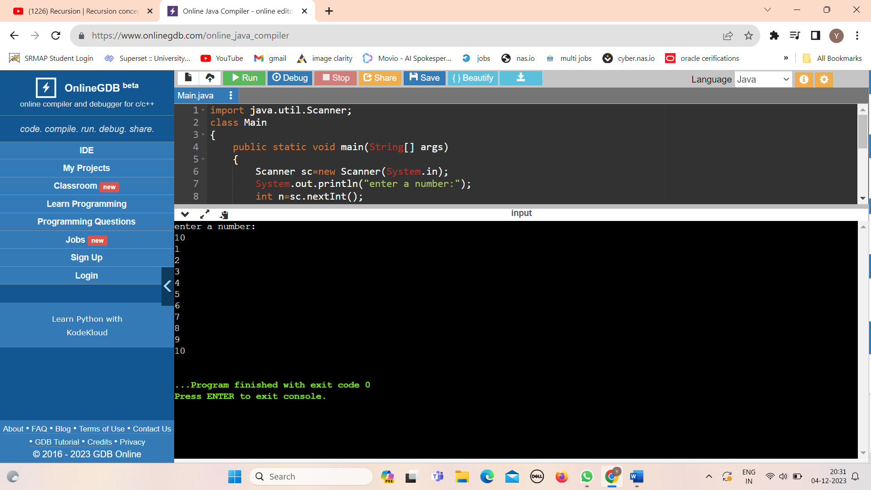

Write a java program to find unique elements in an array using collections?

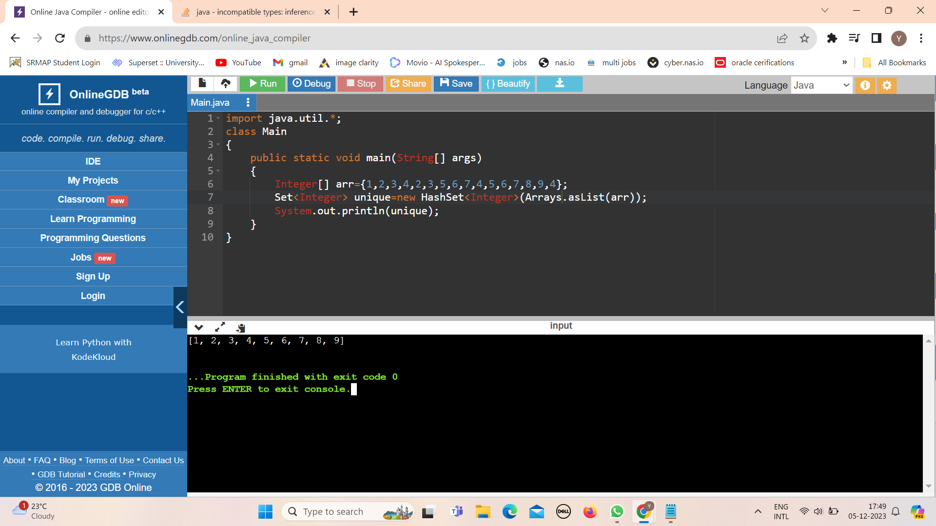

Write a java program to find duplicate elements in an array using collections?

